Calculus 2 Lecture 7.4: Integration By Partial Fractions
How to integrate a partial fraction
- Every polynomial can be factored into a product of linear and/or irreducible quadratic factors
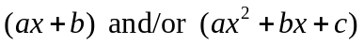
- Every rational, 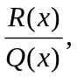 where the degree of 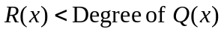can be decomposed into partial fraction.

NOTE for degree 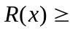Degree of 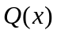 long division of polynomial must happen first.

CASE 1
Distinct linear factors

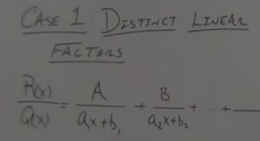

Example
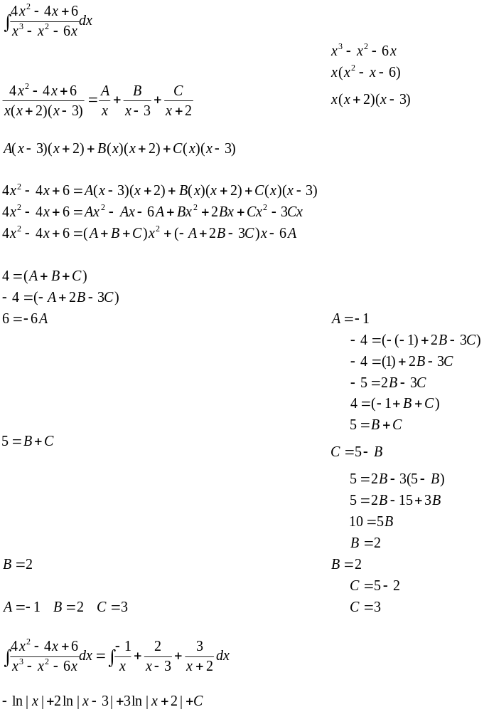

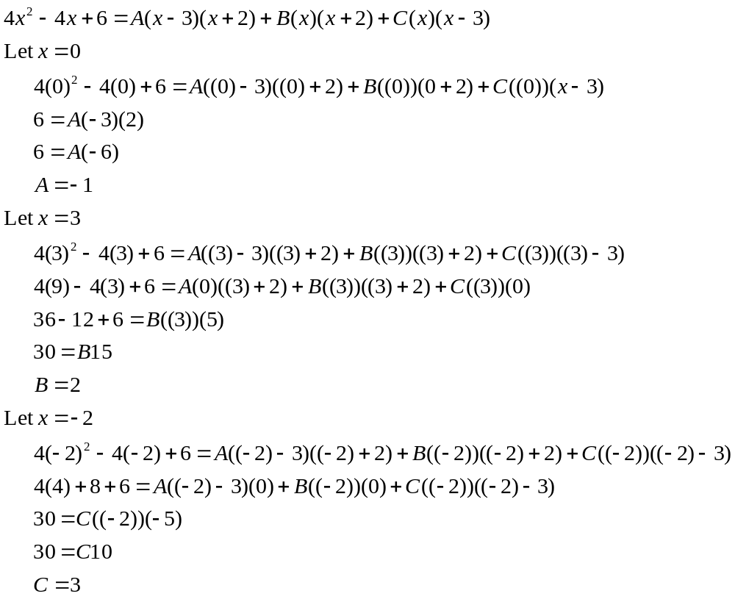
Example
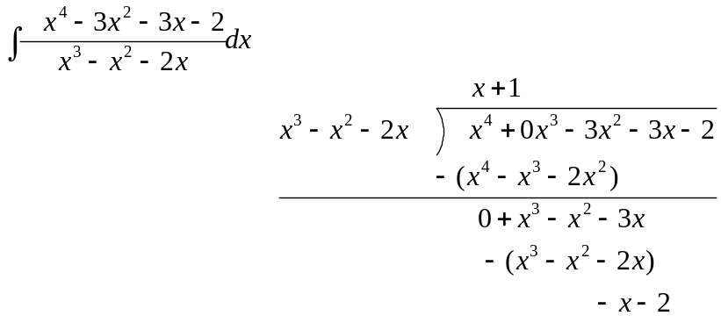
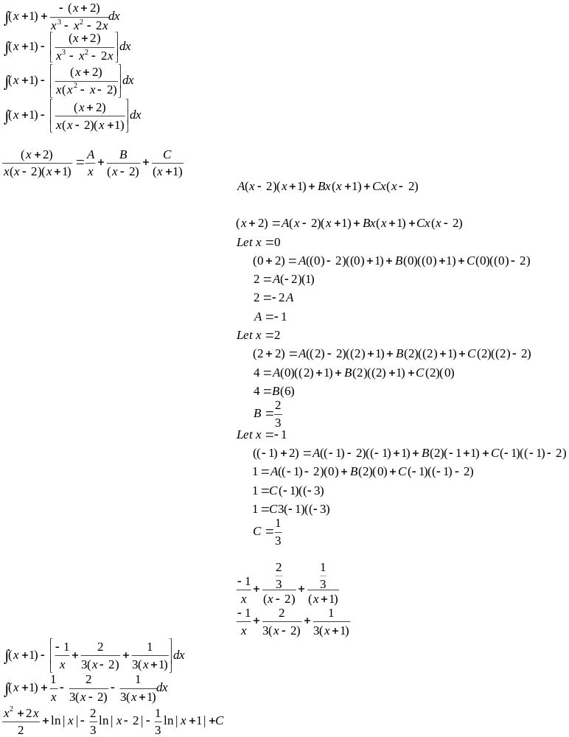
CASE 2
Repeating linear factors:

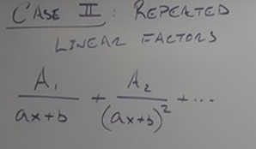
Example
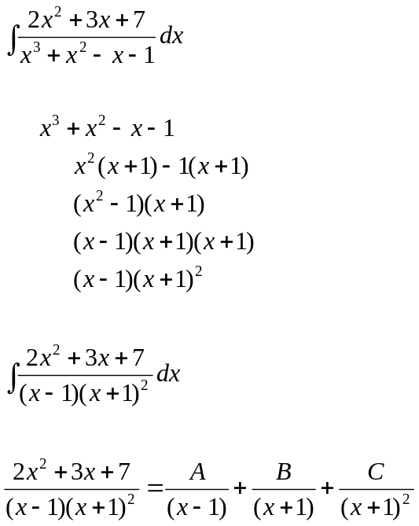

CASE 3
Irreducible quadratic factors:
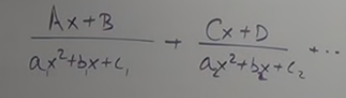

Example
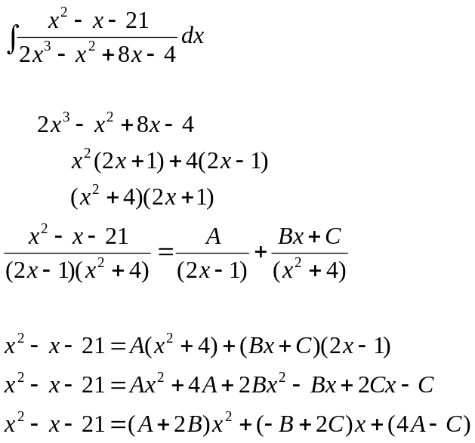
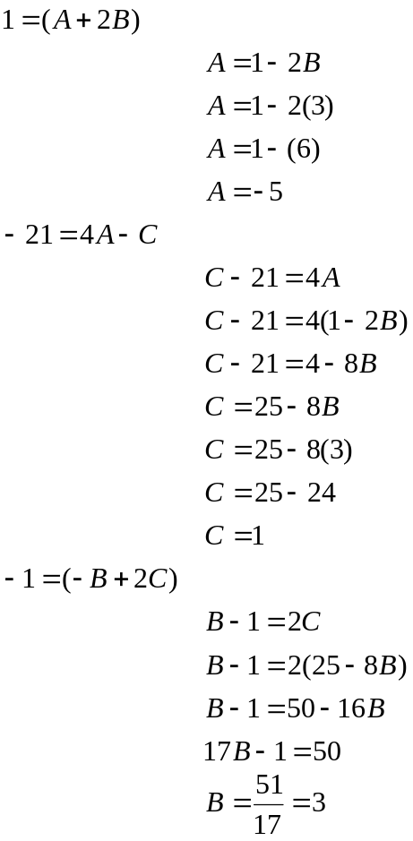

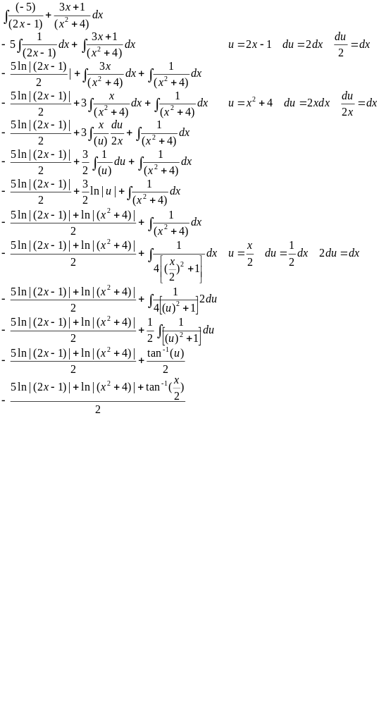
Example

CASE 4
Repeated irreducible quadratic factors:

Example
